CS 255 System Design Document
Isis Jackson
CS255

UML Diagrams

UML Use Case Diagram

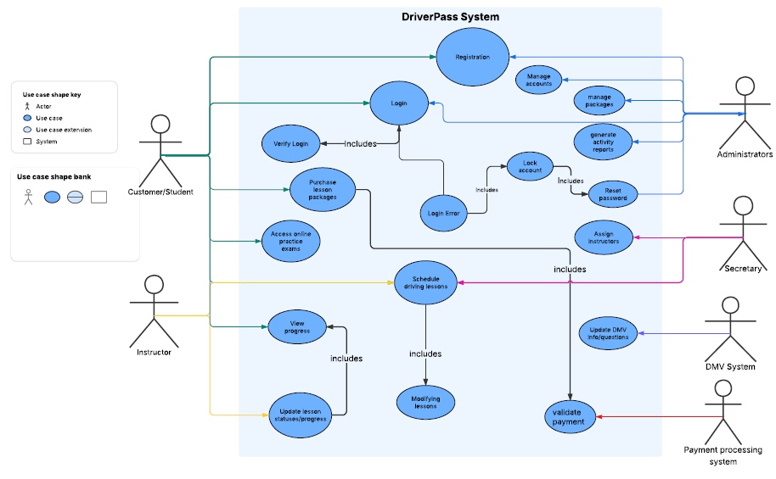

UML Activity Diagrams

Purchase Lesson Packages
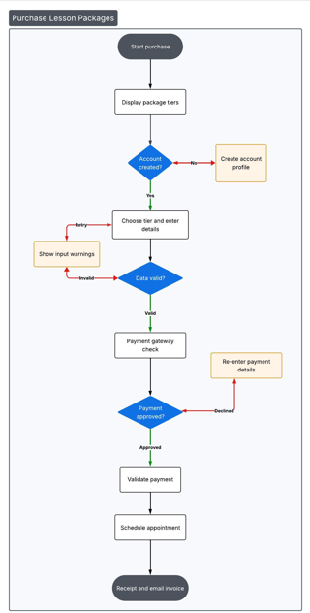

SCHEDULE DRIVING LESSONS

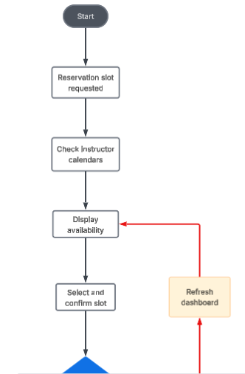
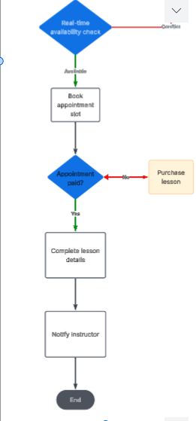

UML Sequence Diagram

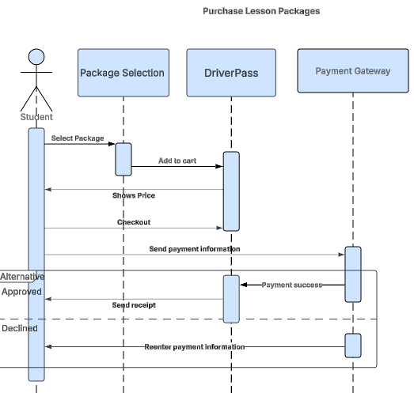

UML Class Diagram
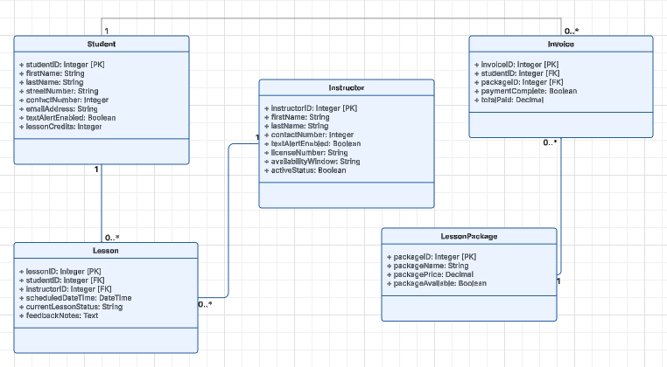

Technical Requirements
[Based on the diagrams you have created, describe the technical requirements of your system. These requirements should address the required hardware, software, tools, and infrastructure necessary for your system design.]
Hardware Requirements:
- A stable and reliable internet connection.
- Sufficient storage capacity for website files and database data.
- A desktop computer, laptop, tablet, or smartphone for accessing the website.
- A dedicated server to host the application and database.
- A firewall to protect the system from unauthorized access, malware, and other security threats.

Software Requirements:
- Web Server: Server to host and manage website traffic.
- Operating System: Windows Server for reliable system performance and stability.
- Database: SQL Server to store and manage user and scheduling data.
- Backup Solution: Automated backups to protect website and database information.
- Security: Threat protection software to prevent malware and unauthorized access.

